1-2 Assignment: Clean Enough to Trust?
Describe your selected data set:
The source of the data set: The data source utilized was the Leading Causes of Death in the United States published by the Centers for Disease Control and Prevention (CDC).
An explanation of whether the source is reputable: This data is available via the U.S. Department of Health and Human Services and the data relating to the cause of death is taken from death certificates which must be signed by a physician and filed in the state of death. Therefore, the data appears to come from a reputable government source. Per the government website this data was published in 2015 and was last updated in 2025 (CDC, 2025). Upon examining the data, it appears to contain information for the period of 1999 to 2017 but not beyond, given that it was first published in 2015 but includes data for 2016 and 2017 it is assumed that the database is updated as soon as the underlying data is available for additional years.
The data types used in each column: The data is comprised of 10,868 rows and six columns, please see Figure 1.1. The six columns present in the data are: Year, 113 Cause Name, Cause Name, State, Deaths, and Age-Adjusted Death Rate, please see Figure 1.2 for the data types. The data is reported based on the year in which the death occurred, and the leading cause of death category is provided in both the 113 Cause Name and Cause Name columns. The data is then presented in the annual totals per state and the District of Columbia as well as the country-wide total labelled “United States”. The Age-Adjusted Death Rate column provides the death rate as adjusted by a statistical process to account for the fact that different causes of death are more likely to be seen in different groups of the US population based on age (Age-Adjusted Rates - Statistics Teaching Tools, 1999). Per the CDC, the age-adjusted death rates per 100,000 people is based on the 2000 population for the years 1999 to 2010 and based on the 2010 census for the years 2011 to 2017 (CDC, 2025).
Identify any data quality issues that could affect analysis:
Missing or null values, inconsistent formats, mislabeled columns, or unusual entries: The Jupyter Notebook shows that no missing or null values are present in the data file, please see Figure 1.3. In scanning the data file, the only inconsistency that was evident was that some of rows were not sorted properly so data from different years was mixed together, please see Figure 2. This demonstrates that some of the data was not properly sorted by year since 2007 data was present in the 2017 section of the data and that on occasion, different death category data was not properly sorted as seen in the data for 2000. This does not necessarily indicate that the data is erroneous but does demonstrate that care is needed when copying and pasting certain segments of the data for further analysis to ensure that all the relevant information is captured. No evidence was found that the data contained mislabeled columns or unusual entries.
Evaluate the overall quality and cleanliness of the data:
Support your conclusion with specific examples: Upon closer examination of the data there appears to be redundancy in the data in that the deaths are reported by state and then combined and reported for the entire country leading to duplicate deaths, please see Figure 3, which presents an example for the year 2017 in the unintentional injuries category. This example demonstrates that if both the individual states and the combined nationwide total are both used, the number of deaths will be doubled to 339,872 deaths instead of 169,936 deaths, grossly overreporting the actual deaths that occurred in the country for the given time period. Therefore, it is necessary to filter out these duplicates prior to analyzing the data. Additionally, when filtering for the total US population data the “All Causes” amounts per year do not agree to the total deaths by summing the ten death categories, since the data only presents the ten leading causes of death (CDC, 2025) leaving the remainder unclassified, please see Figure 4. This figure demonstrates that more deaths are included in the “All Causes” category than are accounted for than the ten death categories, these additional deaths represent “Uncategorized Deaths”, and these uncategorized deaths represent approximately 24% of the total deaths reported for the period of 1999 to 2017.
Explain how the data quality issues might impact your ability to analyze the data effectively: With regards to this data, a quality concern could be the timeliness of the information being provided as this data is almost a decade behind because the last year included was 2017. This does not indicate that the data is invalid, but it does raise the question of its usefulness, especially given the COVID-19 pandemic which would be particularly relevant for mortality analysis from 2020 onward. Data of this nature often needs to be more timely to be useful in analyzing the current leading causes of death and developing models to estimate future trends to help aid in the allocation of medical resources.
Determine what kinds of questions or insights this data set could help answer: Since this data is broken up by year and state it could be utilized to determine trends in the deaths year over year on a national or state level per the ten leading causes of death categories. As mentioned previously, the data only classifies the death if the cause was a leading cause of death, leaving the rest of the deaths unclassified which is an analysis limitation if the research needs to involve the study of another cause of death like dementia. Additionally, as mentioned previously the timeliness of additional data could also present a limitation in how the data could be applied; it could be used for historical analysis but for future predictions it may be limited given the years for which the data is available.
References

Age-Adjusted Rates - Statistics Teaching Tools. (1999, April). Retrieved from New York State Department of Health: https://www.health.ny.gov/diseases/chronic/ageadj.htm
CDC. (2025, April 21). NCHS - Leading Causes of Death: United States. Retrieved from Data.gov: https://catalog.data.gov/dataset/nchs-leading-causes-of-death-united-states

Figure 1: Jupyter Notebook Outputs
Figure 1.1: Data Shape
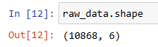
Figure 1.2: Column Data Types
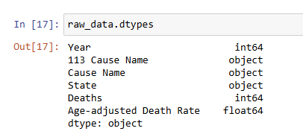
Figure 1.3: Missing or Null Values
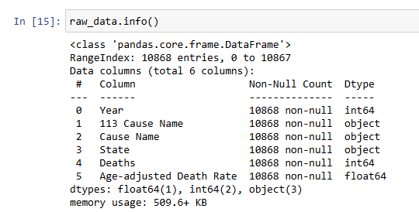
Figure 2: Improper Sorting Examples
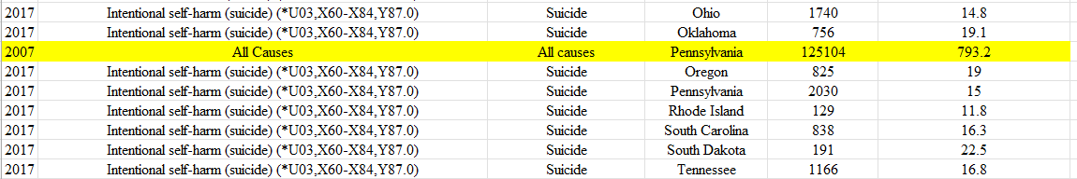

Figure 3: Duplicate Deaths Example for 2017 Unintentional Injuries (CDC, 2025)
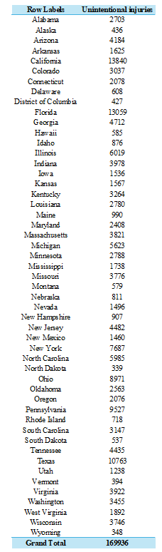

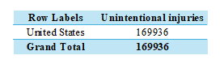

Figure 4: Annual Unclassified Deaths (CDC, 2025)

